Data from the MacKenzie, Kawka and Moon Rivers was provided in a set of Excel workbooks with the BLTR cpue /100m computed from samples in a number of years. A preliminary plot of the data (Figure 1) shows an existing trend (but this could not be detected (see below). A linear mixed model was used to extract the temporal process error (year-specific effects) and the within-year sampling error as shown below:

System Measure slope slope.se slope.p SD.sampling SD.process

1 Kakwa BLTR_100m 0.06 0.02 0.02 1.38 0.39

2 MacKenzie BLTR_100m 0.11 0.04 0.09 1.78 0.40

3 Moon BLTR_100m 0.05 0.04 0.27 1.35 0.00

The estimated trends ranged from 5 to 11% increase per year but there was evidence that the trend differed from 0 only for Kakwa (p=.02). More importantly, the sampling and process standard deviations are extracted. Rather surprising, there was no evidence of process error for Moon watershed.

These standard deviations were used to estimate the power for different number of sites/year to detect a 10%, 30%, 50%, 100% and 200% increase over 5 or 10 years (Figures 2a, 2b, 2c).

Because of the large process error for the Mackenzie and Kakwa systems, the power is essentially flat as the number of samples increase/year. With large process error, the limiting factor is the number of years of sampling and not the sampling within each year. In no situations for these two systems, could enough sampling be done to detect even the most extreme trends after 5 or 10 years.

Because the estimated process error was 0 for the Moon river system, 30 sites/year would be sufficient to detect the larger trends over 5 or 10 years, but not the smaller trends until well over 100 sites/watershed were sampled.

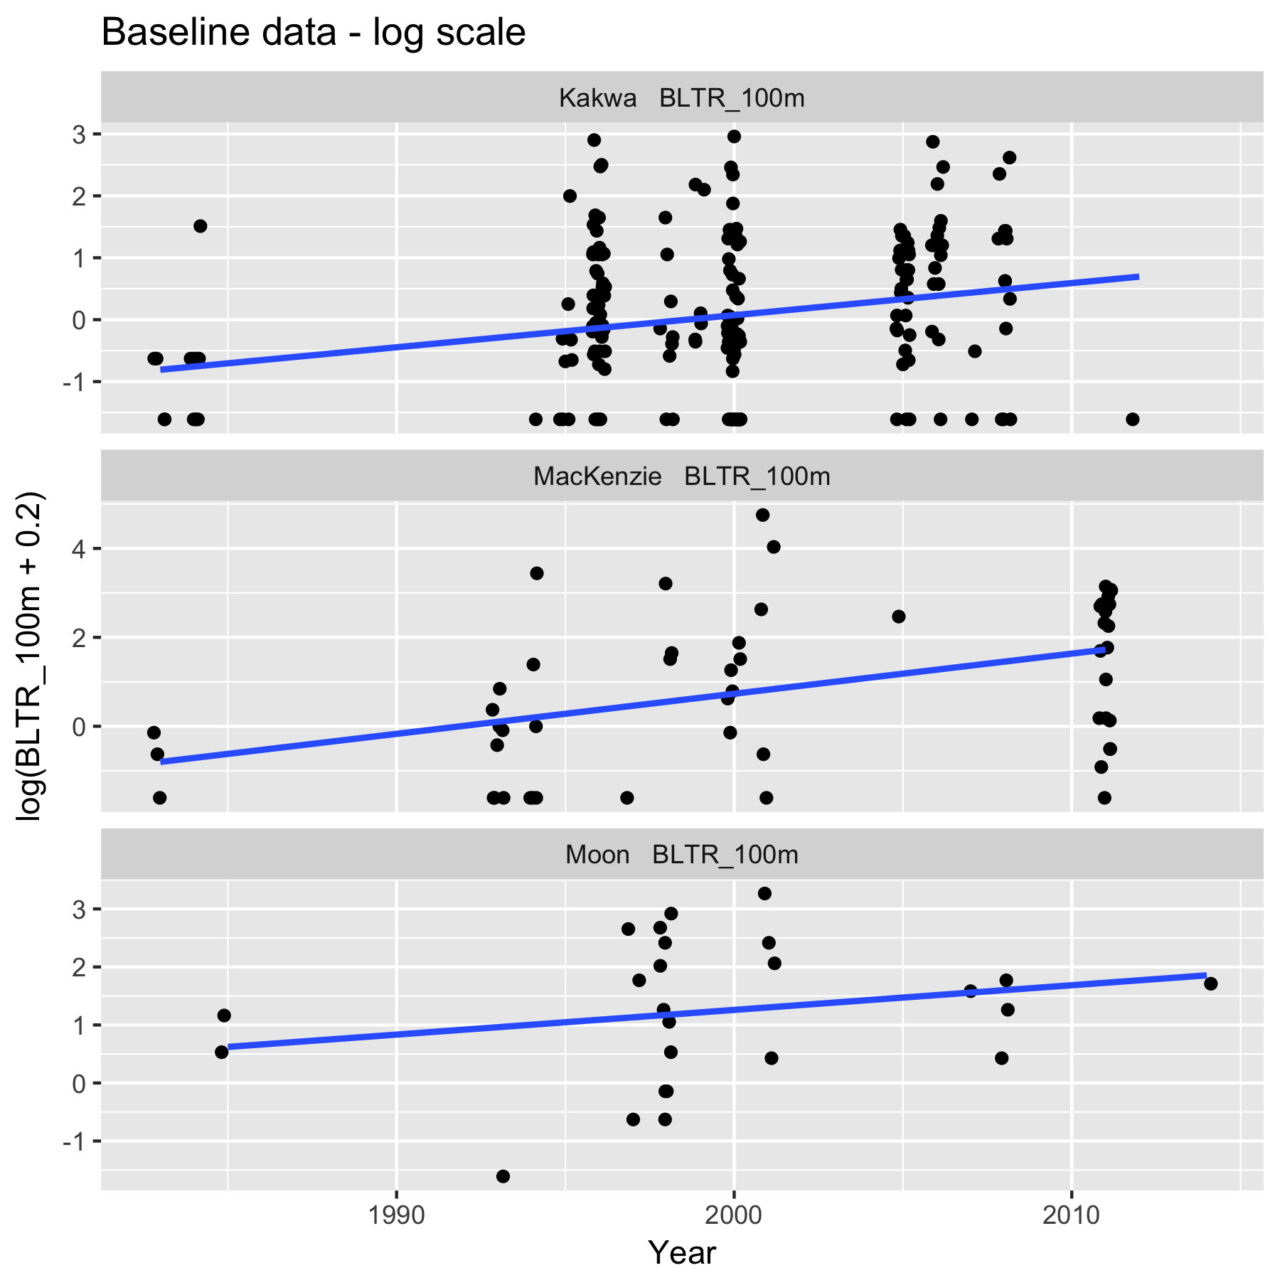

Figure 1. Preliminary plot (on the log-scale with 0.2 fish/100 m added to avoid taking log(0)).

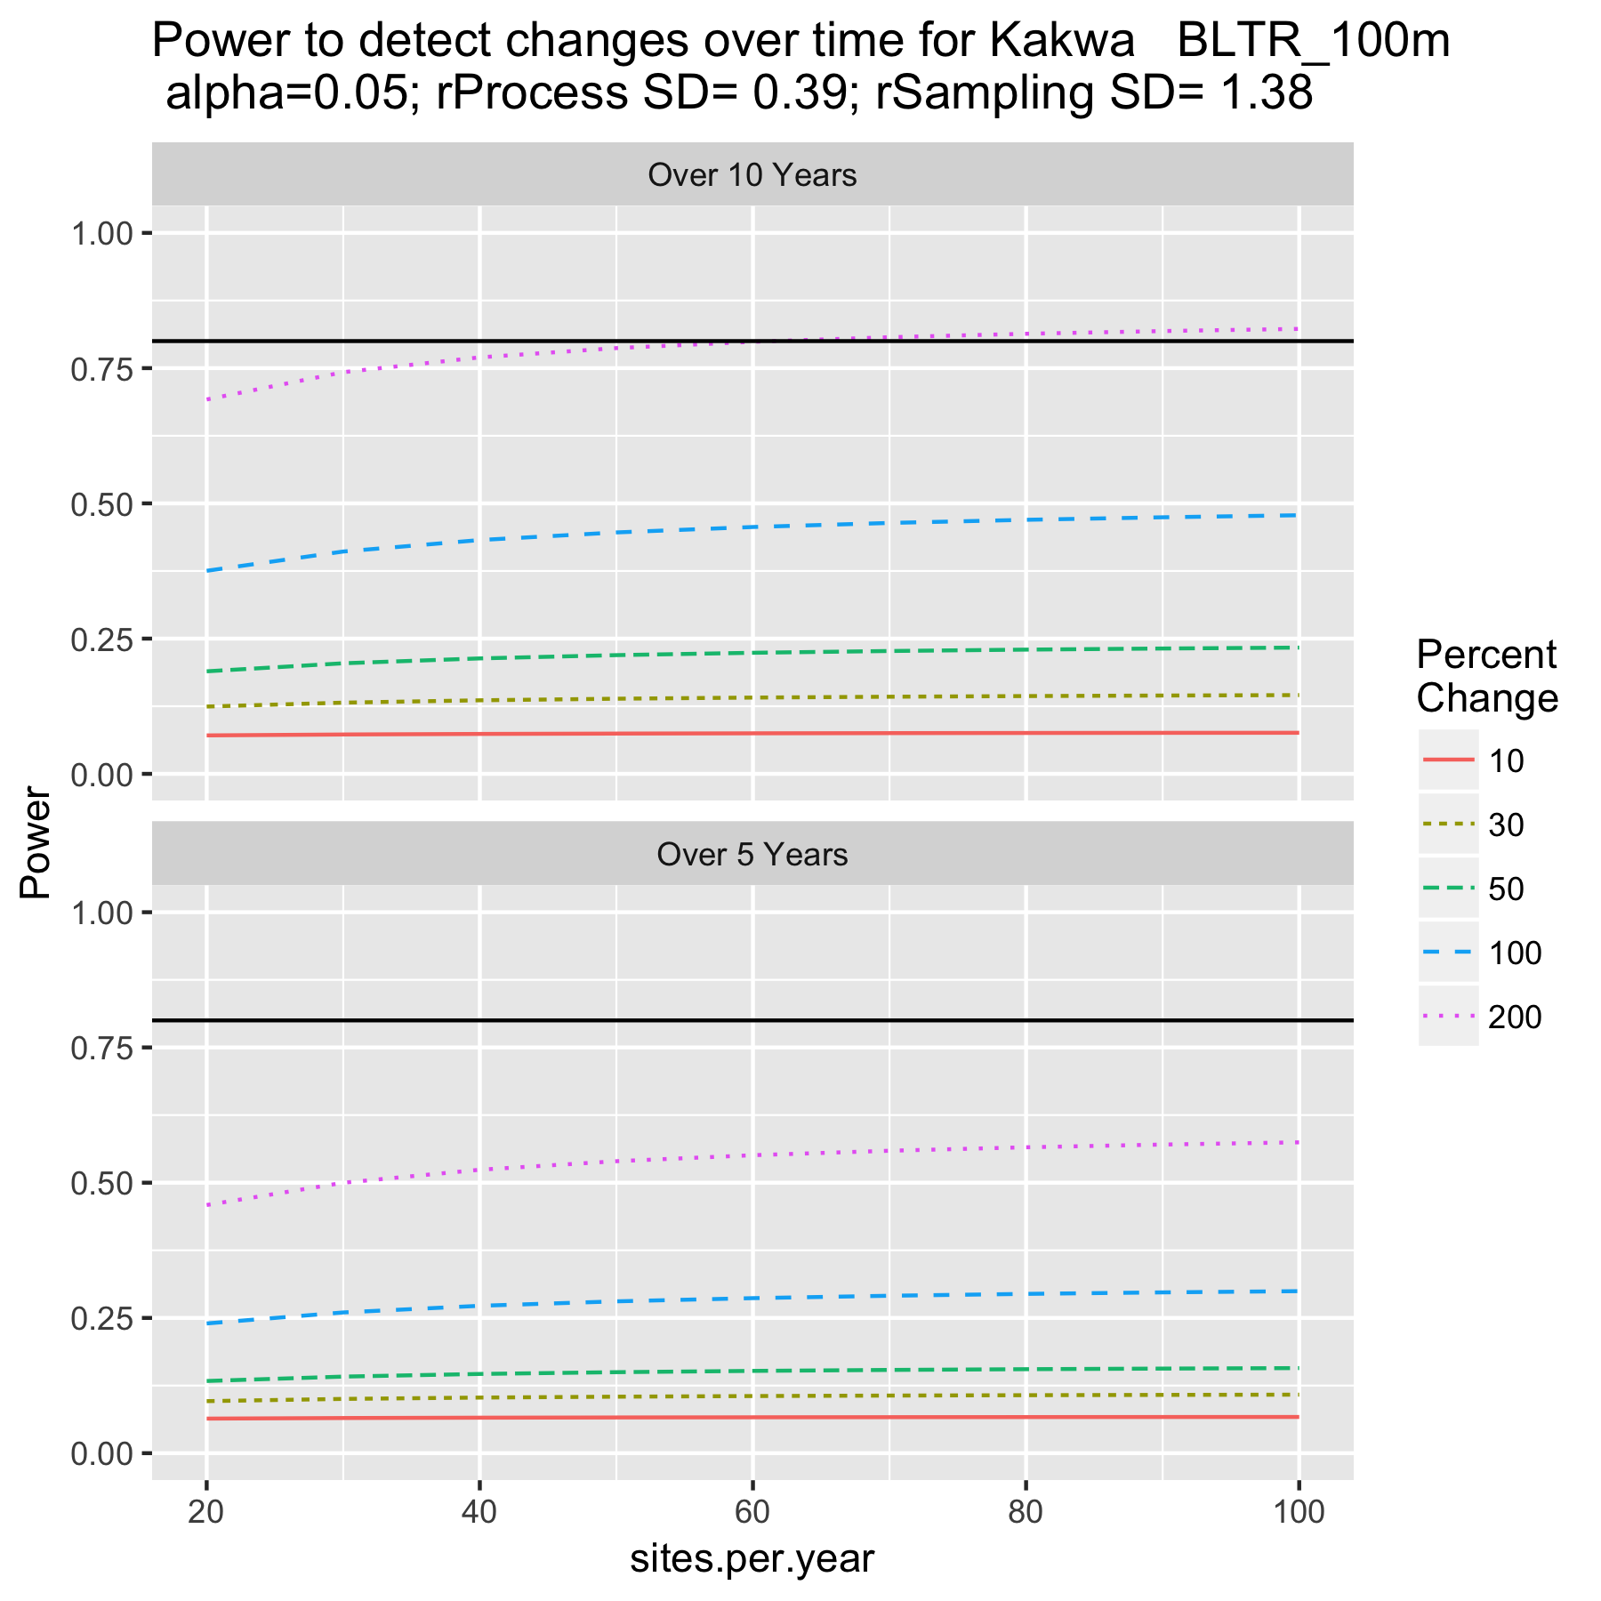

Figure 2a. Power to detect trends at Kakwa.

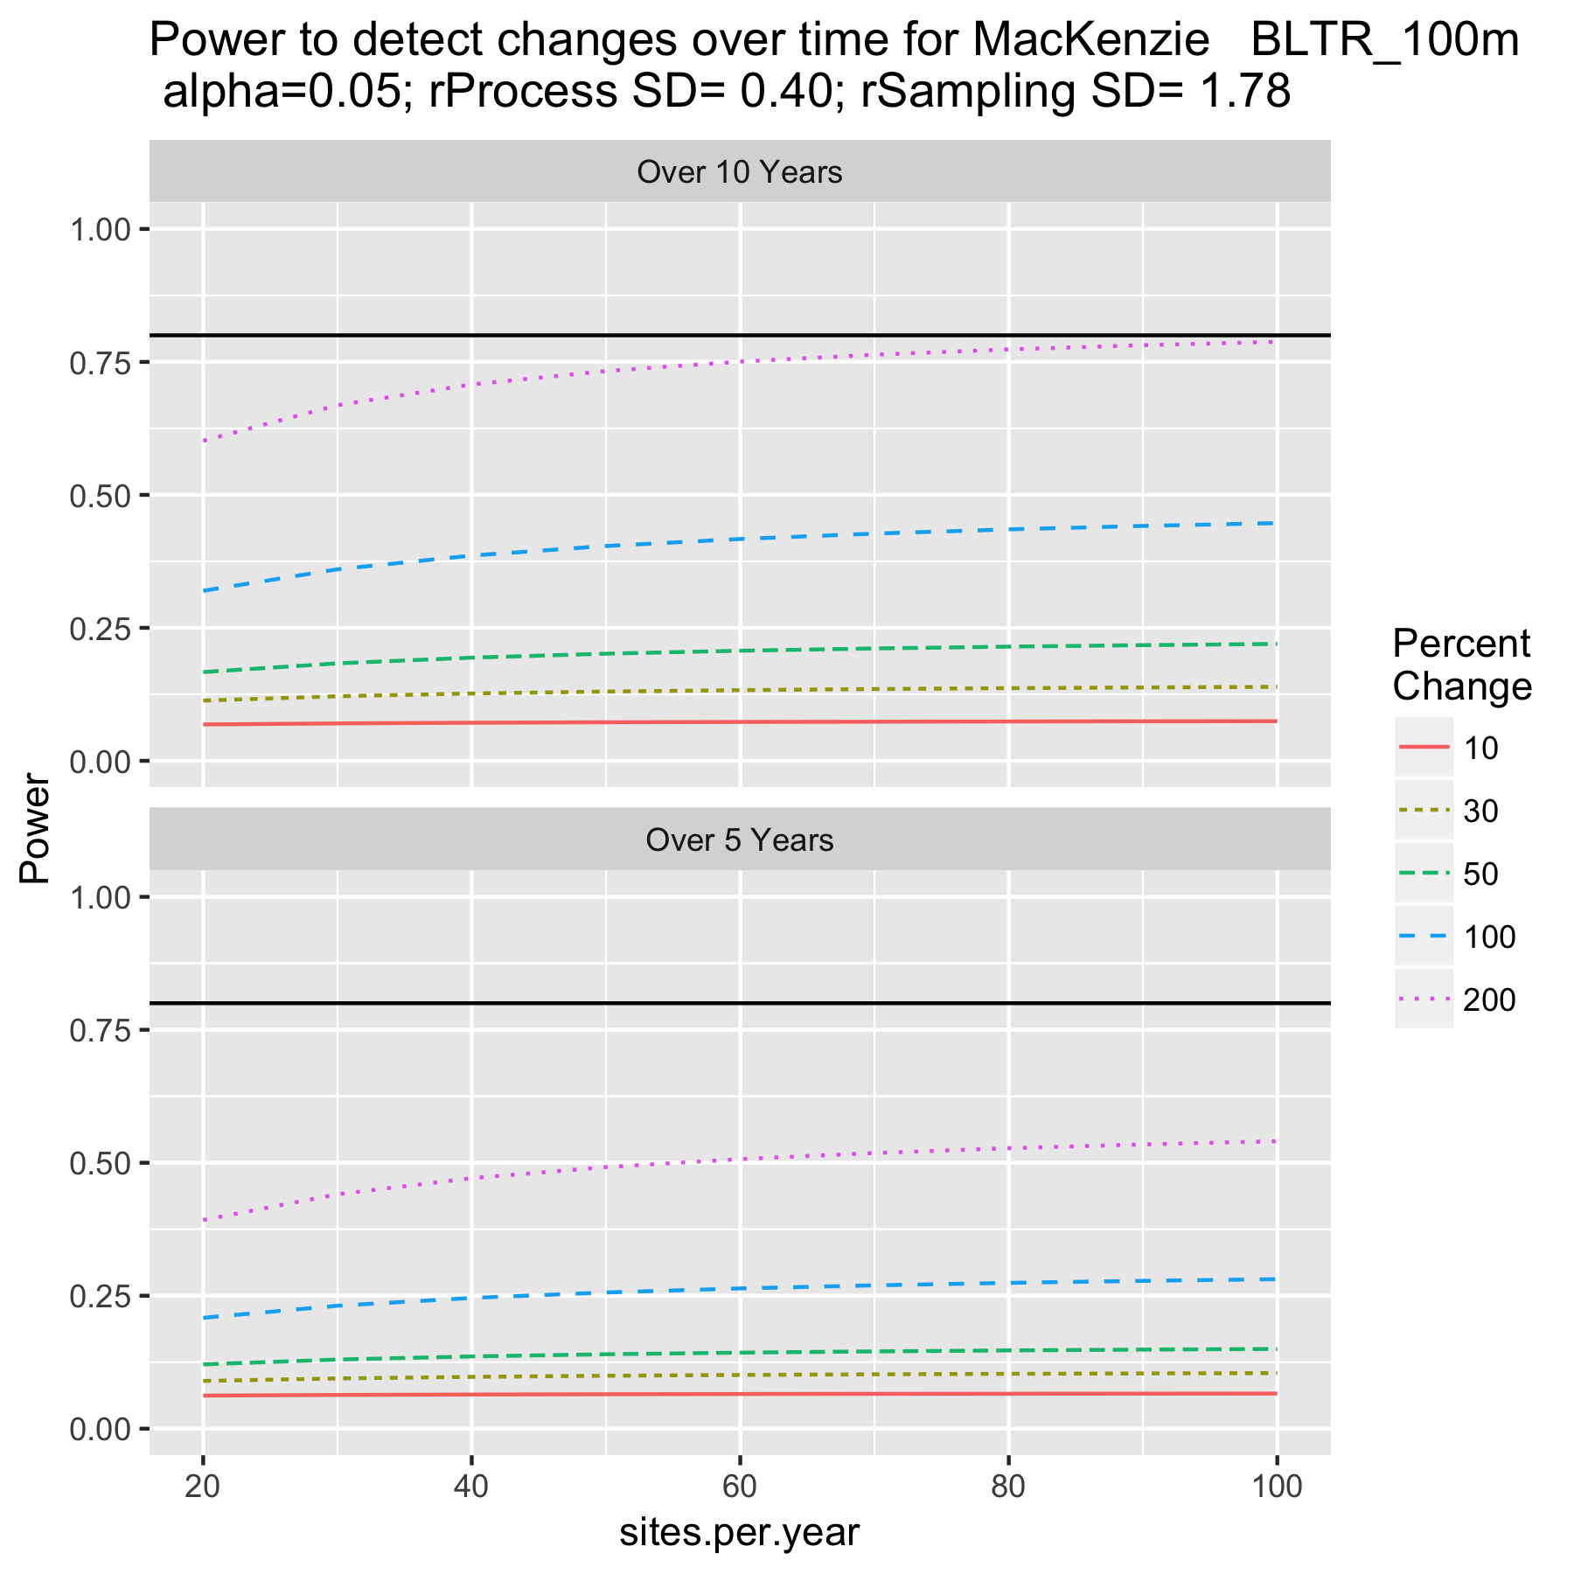

Figure 2b. Power to detect trends at MacKenzie.

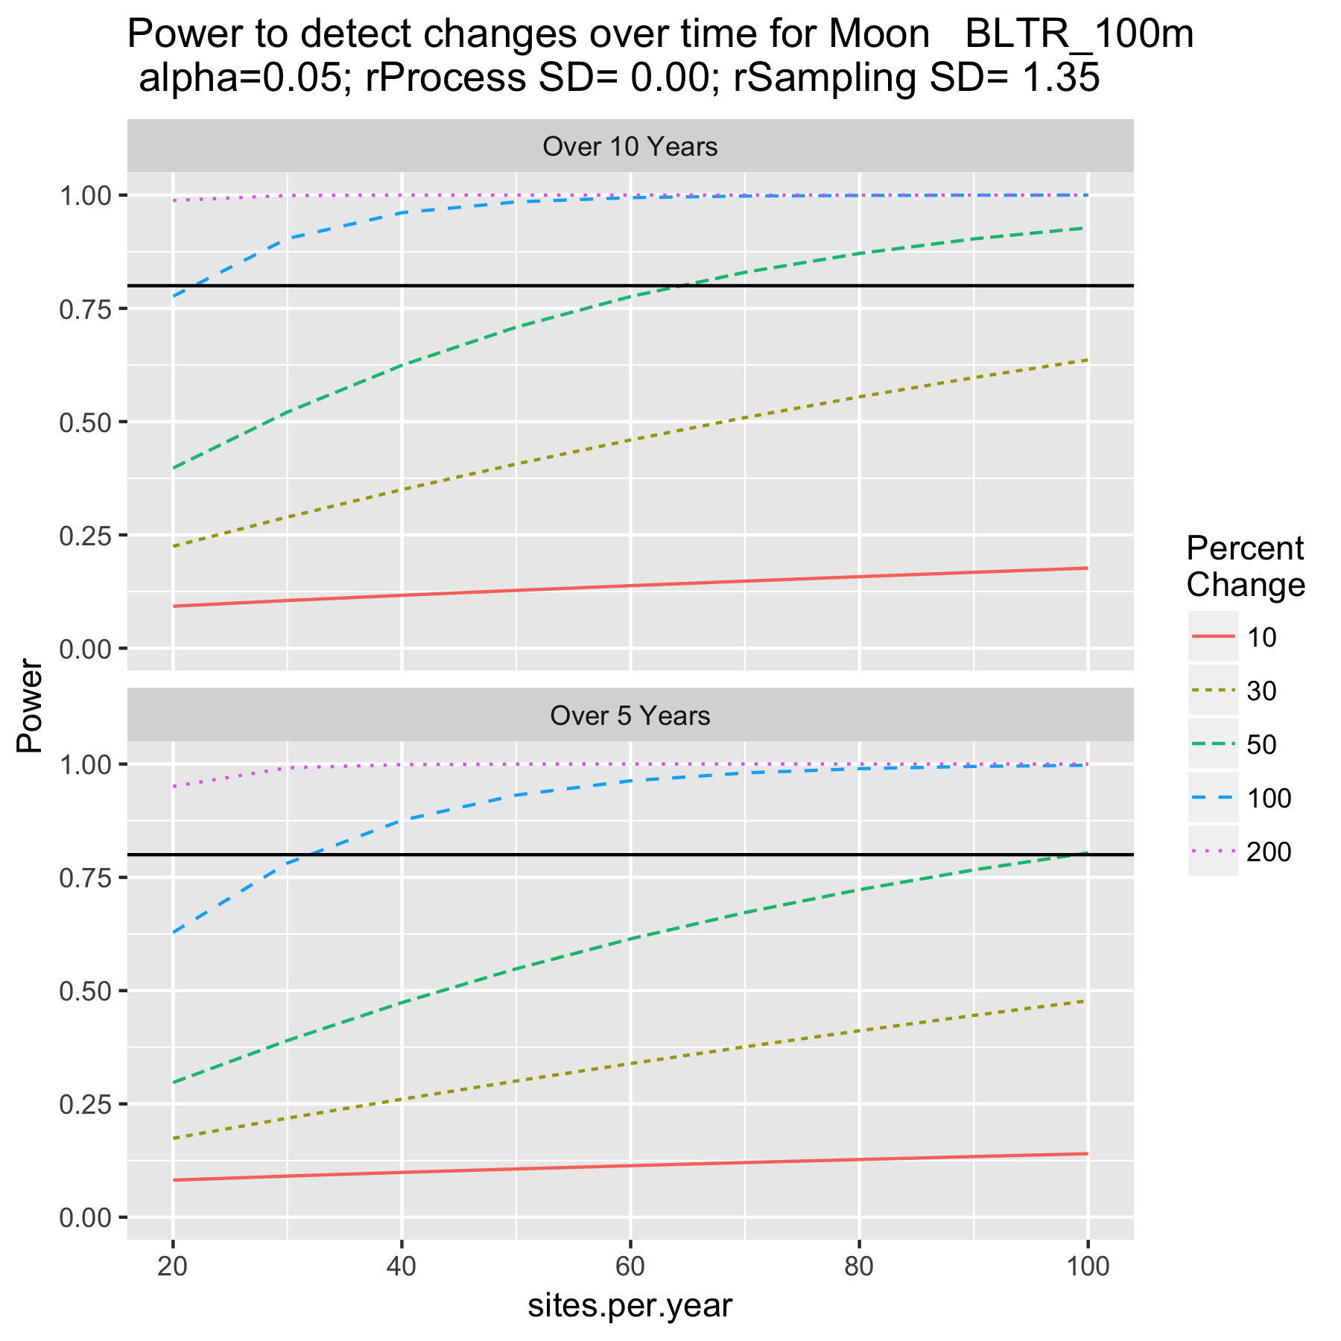

Figure 2c. Power to detect trends in Moon system.